**Ansible Playbook (Linux – Windows) using Winrm**

1. Install winrm in Linux server

sudo yum install -y python2-winrm

sudo yum -y install python-pip

sudo pip install pywinrm

1. Create a Windows Server 2019 Instance in AWS
2. Open Winrm-https port in security groups

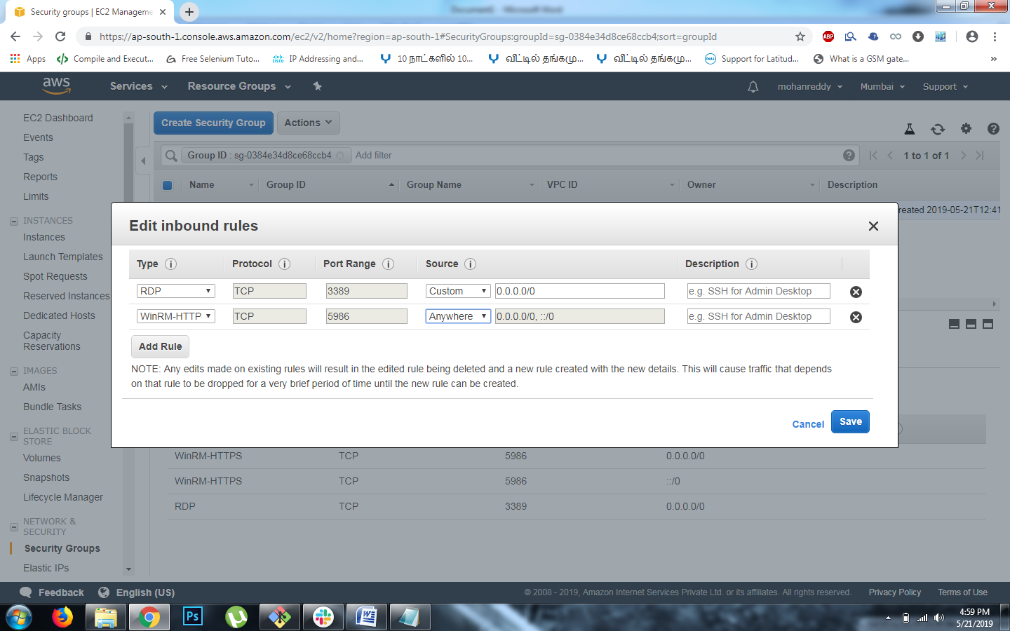

1. Login to Windows Server using Remote Desktop tool

Connect -> Click Get Password

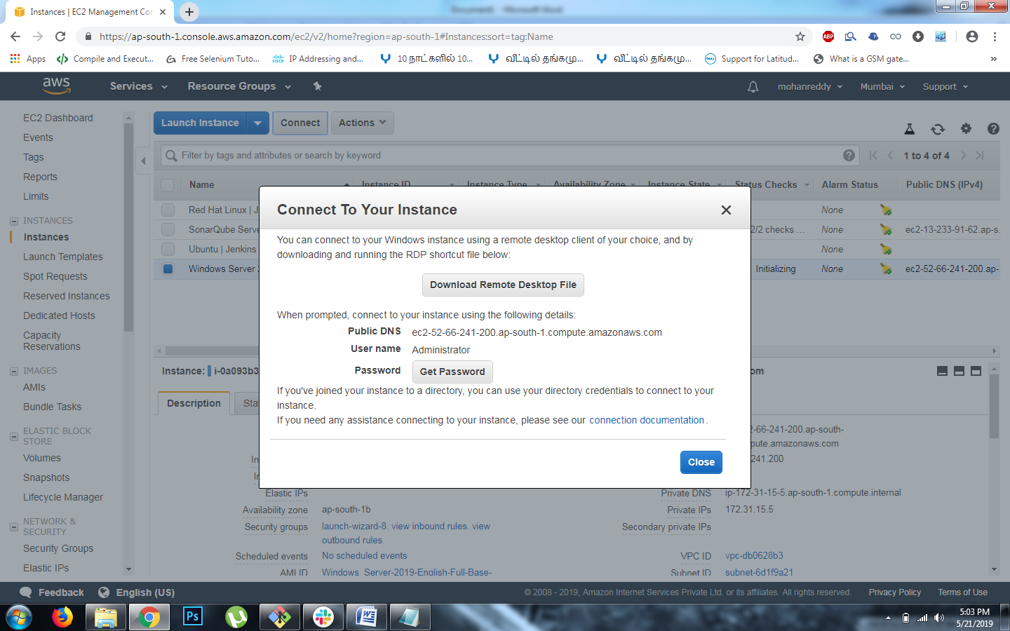

Click -> Choose File & select your AWS pem file & Click Decrypt Password

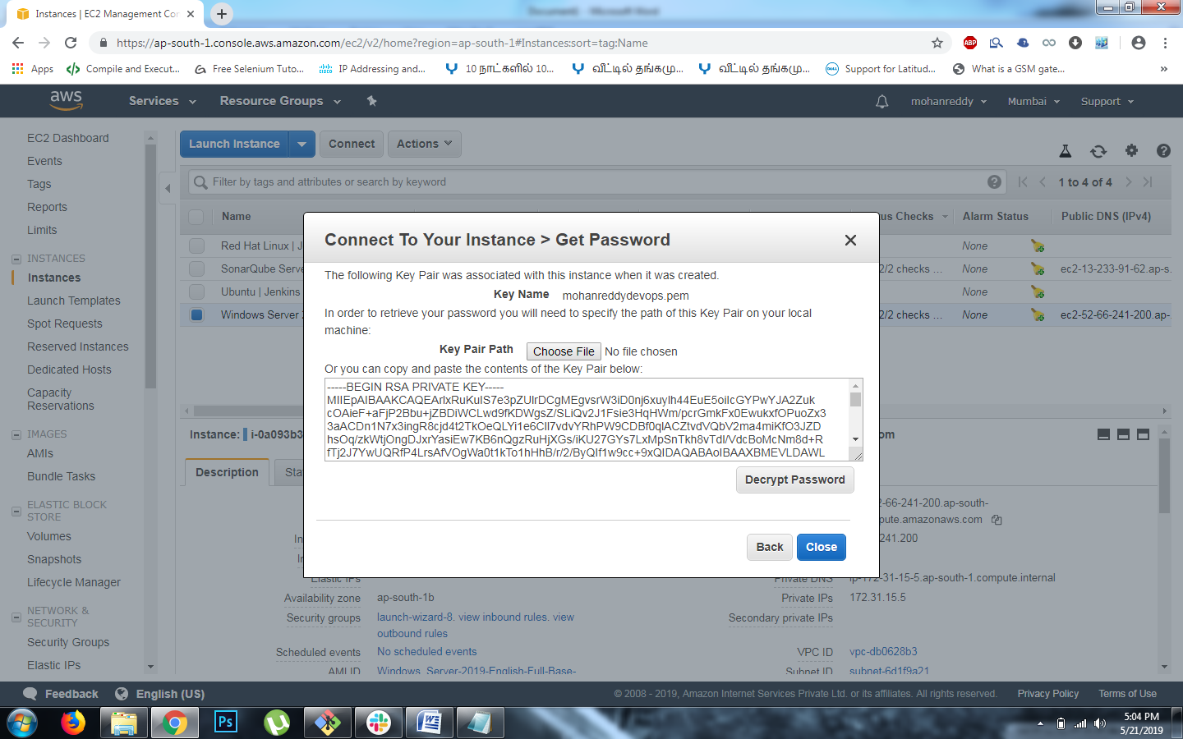

Copy -> Public DNS, User Name & Password

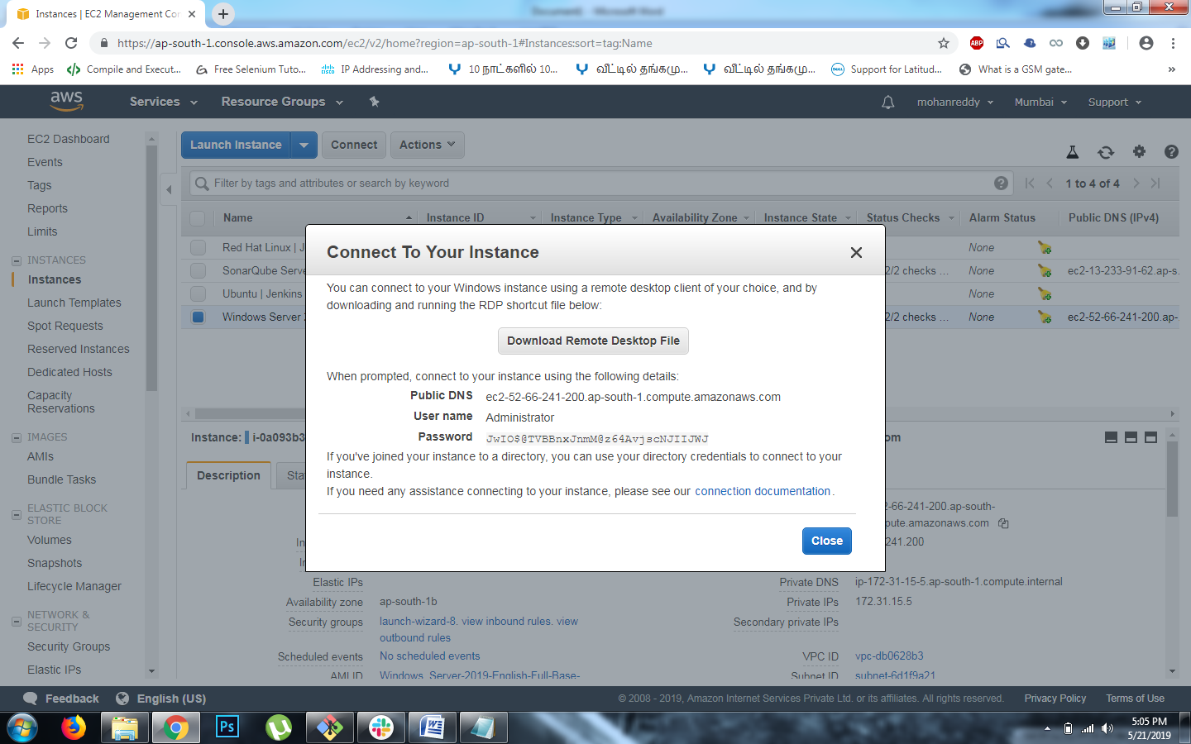

Open Remote Desktop Connection –> Paste Public DNS in place of Computer

& Click -> Connect

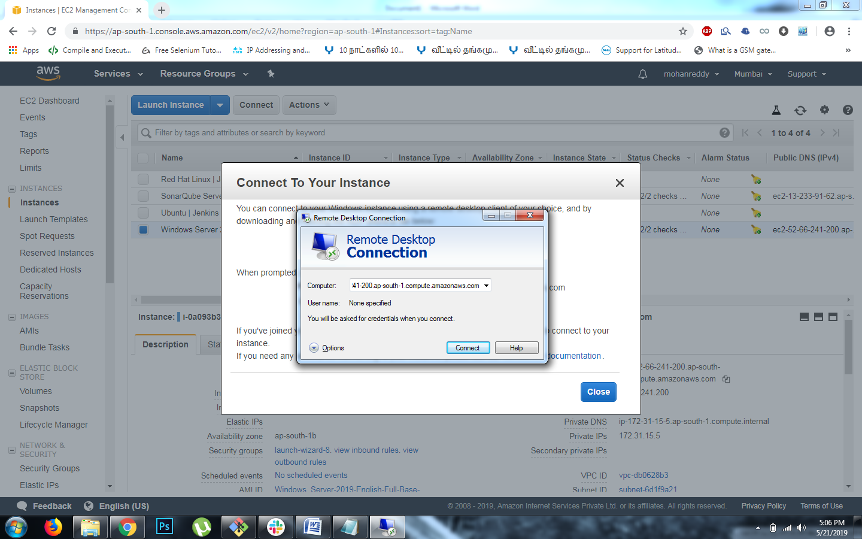

Provide Username & Password and Click -> OK

Now Remote Desktop will connect to the Windows Server 2019

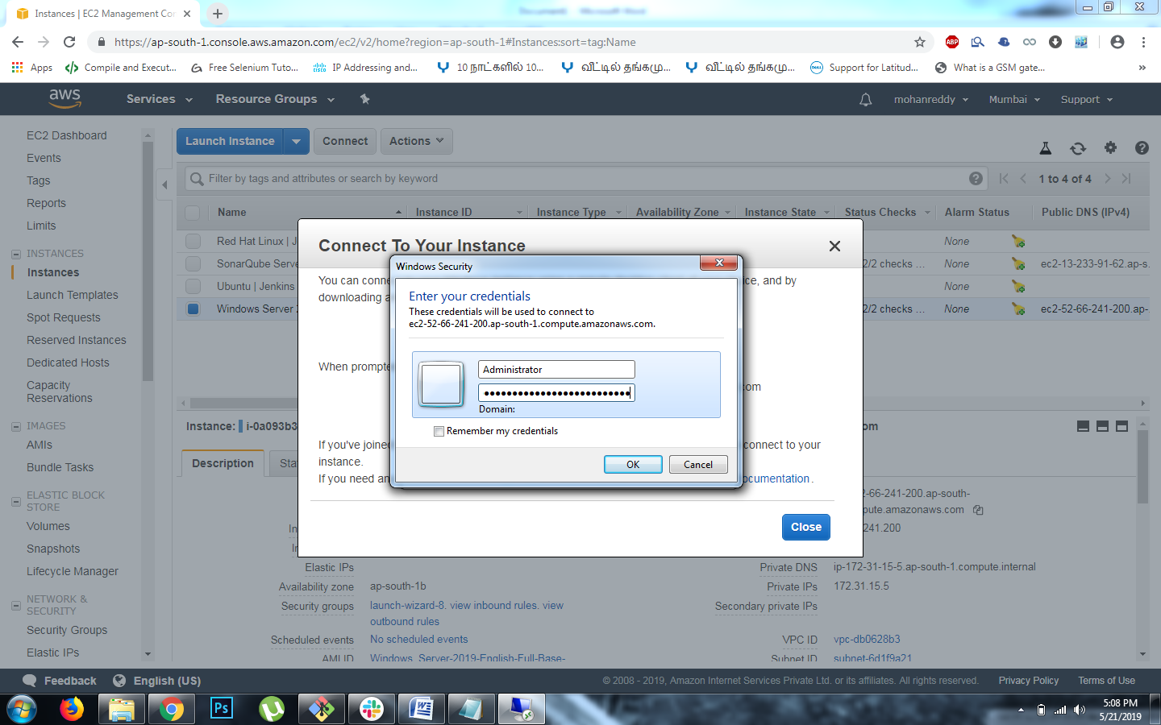

Windows Server 2019 Connected



1. Open Windows Powershell and Check for version. It is above 3.0, so we can configure winrm now (use Get-Host command to check version)

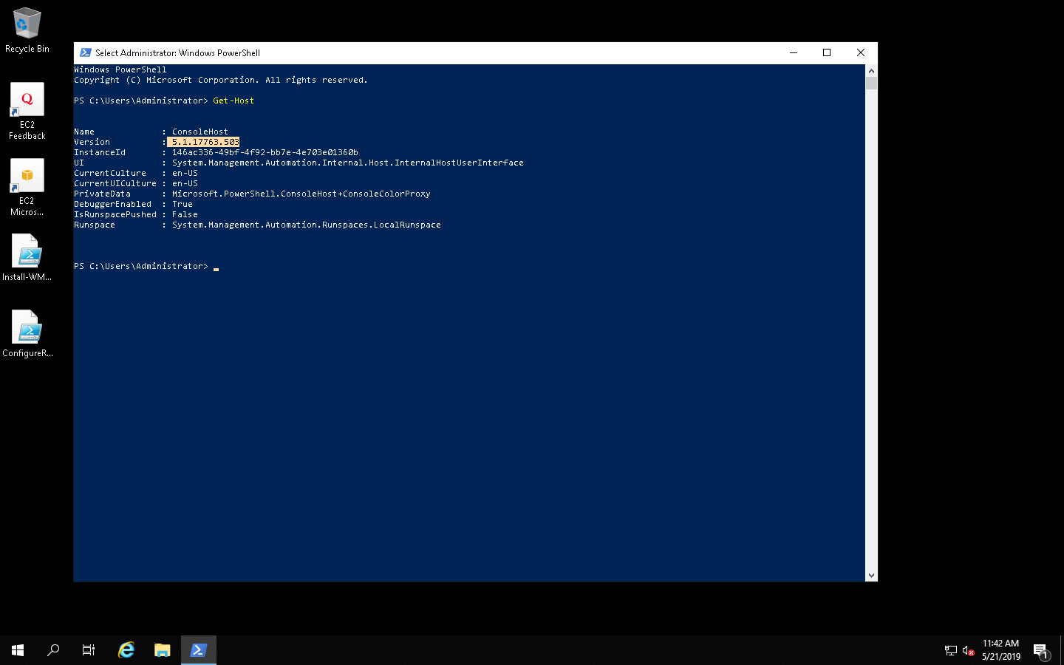

1. Configure Winrm
   1. Winrm Memory Hotfix

Goto this link

<https://github.com/jborean93/ansible-windows/blob/master/scripts/Install-WMF3Hotfix.ps1>

Copy the code and save it in Windows Server Machine Desktop as [Install-WMF3Hotfix.ps1](https://github.com/jborean93/ansible-windows/blob/master/scripts/Install-WMF3Hotfix.ps1)

Open Windows Powershell and go to Desktop (cd ~/.Desktop)

Execute the following command

powershell**.**exe -ExecutionPolicy ByPass **-File** **Install-WMF3Hotfix.ps1** –Verbose

* 1. Winrm Setup

Got to this link <https://github.com/ansible/ansible/blob/devel/examples/scripts/ConfigureRemotingForAnsible.ps1>

Copy the code and save it in Windows Server Machine Desktop as [ConfigureRemotingForAnsible.ps1](https://github.com/ansible/ansible/blob/devel/examples/scripts/ConfigureRemotingForAnsible.ps1)

Open Windows Powershell and go to Desktop (cd ~/.Desktop)

Execute the following command

powershell**.**exe -ExecutionPolicy ByPass **-File** **ConfigureRemotingForAnsible.ps1**

* 1. Winrm Listener

Execute this command in Powershell to know about the winrm listener port details

winrm enumerate winrm**/**config**/**Listener

Winrm uses Port 5986 for HTTPS & 5985 for HTTP

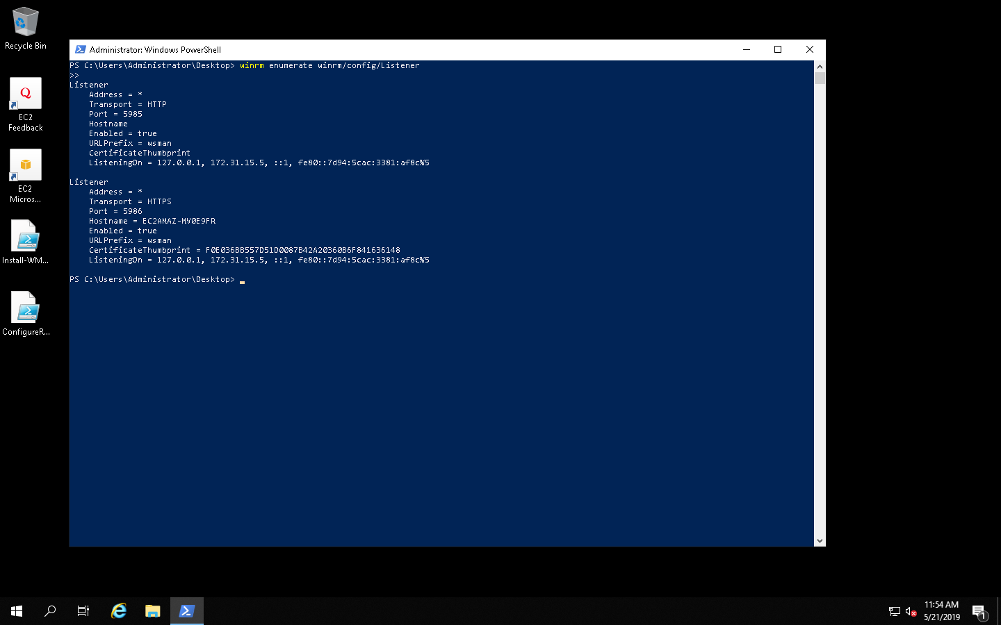

1. Configure Windows Host in Ansible Server in /etc/ansible/hosts

**[windowsServers]**

PRIVATE IP ansible_password=PASSWORD ansible_connection=winrm ansible_port=5986 ansible_user=Administrator ansible_winrm_server_cert_validation=ignore

(Note: Replace PRIVATEIP & PASSWORD with your Windows Server 2019 Instance Credentials)

1. Ping Windows Server using the command

ansible **windowsServers** –m win_ping



1. Write a playbook to Install Git & Notepad++ in Windows Server 2019

- hosts: **windowsServers**

tasks:

- name: Install git

win_chocolatey:

name: git

state: present

- name: Install notepad++

win_chocolatey:

name: notepadplusplus

state: present

1. Execute Playbook to install Git and Notepad++ in Windows Server 2019

ansible-playbook win.yml

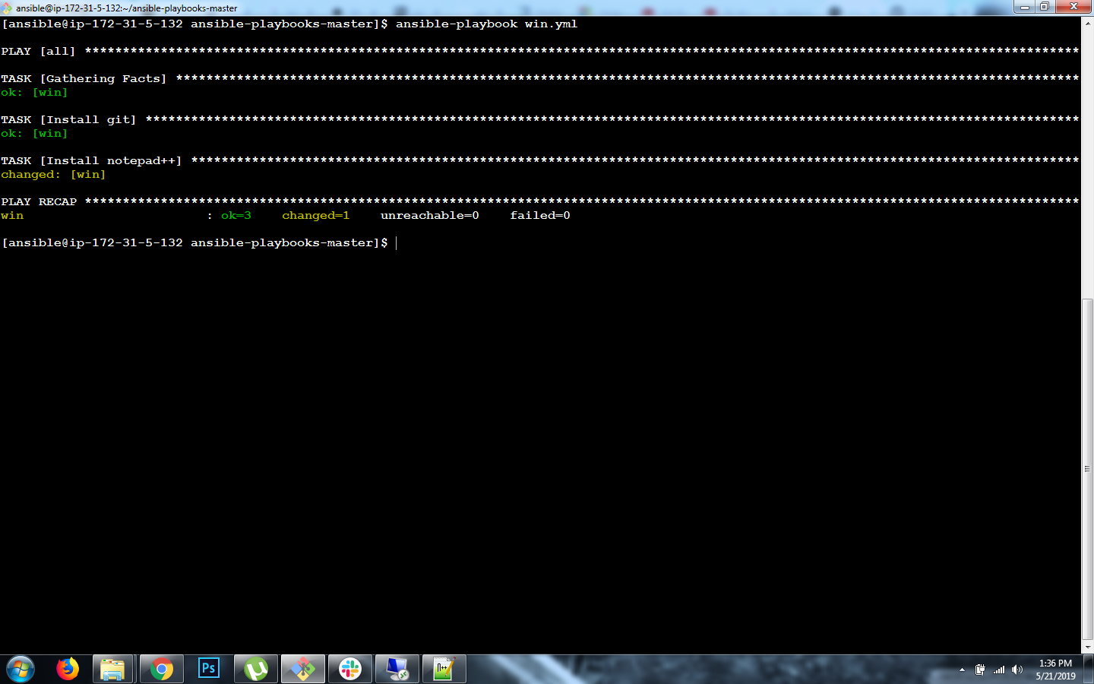

11 . Check the Installed Git & Notepad++ in Windows Server 2019

